FOOD ORDERING BEHAVIOUR AND CONSUMER TRENDS
A Structured Analysis of Choices and Habits
Final Project Report

Prepared By: Tallam Sai Phani Krishna
Project Domain: Business Intelligence & Data Analytics
Tools Used: Tableau Public, Microsoft Excel, GitHub, CSV Dataset
Date: July 2026

TABLE OF CONTENTS

1. INTRODUCTION
1.1 Project Overview
1.2 Purpose

2. IDEATION PHASE
2.1 Problem Statement
2.2 Empathy Map Canvas
2.3 Brainstorming

3. REQUIREMENT ANALYSIS
3.1 Customer Journey Map
3.2 Solution Requirements
3.3 Data Flow Diagram
3.4 Technology Stack

4. PROJECT DESIGN
4.1 Problem Solution Fit
4.2 Proposed Solution
4.3 Solution Architecture

5. PROJECT PLANNING & SCHEDULING
5.1 Project Planning

6. FUNCTIONAL AND PERFORMANCE TESTING
6.1 Performance Testing

7. RESULTS

8. ADVANTAGES & DISADVANTAGES
8.1 Advantages
8.2 Disadvantages

9. CONCLUSION

10. FUTURE SCOPE

11. APPENDIX
11.1 Source Code
11.2 Dataset Link
11.3 GitHub Repository
11.4 Project Demo Link

1. INTRODUCTION

1.1 Project Overview
The food delivery industry has experienced significant growth in recent years, leading to an increase in customer transactions and the generation of large volumes of data. Organizations collect information related to customer preferences, cuisine choices, delivery performance, order value, and customer ratings. However, transforming this raw data into meaningful business insights remains a challenge.
This project, Food Ordering Behaviour and Consumer Trends, addresses this challenge by utilizing Tableau to develop an interactive Business Intelligence dashboard. The dashboard enables users to analyze customer behaviour, identify ordering trends, evaluate delivery performance, and monitor revenue through intuitive visualizations. By converting raw transactional data into interactive dashboards, the project supports effective business analysis and informed decision-making.

1.2 Purpose
The purpose of this project is to analyze food ordering behaviour using Business Intelligence techniques and provide meaningful insights through interactive Tableau dashboards.
The project aims to:
- Analyze customer ordering behaviour.
- Identify popular cuisines and meal preferences.
- Compare city-wise business performance.
- Evaluate revenue contribution across different categories.
- Assess delivery efficiency and customer satisfaction.
- Support business decision-making through visual analytics.
The developed dashboard serves as an effective analytical tool for business analysts, operations managers, and decision-makers by enabling them to explore trends and monitor key performance indicators interactively.

2. IDEATION PHASE

2.1 Problem Statement
Food delivery platforms generate a large amount of customer and operational data every day. Although this data contains valuable business information, it is often difficult to identify customer behaviour patterns, operational inefficiencies, and revenue opportunities without proper analytical tools.
Businesses require an effective solution to transform raw data into meaningful visual insights that support strategic planning and operational improvements.
This project addresses this problem by developing an interactive Tableau dashboard that enables users to analyze food ordering behaviour, customer preferences, revenue trends, and delivery performance through Business Intelligence techniques.

2.2 Empathy Map Canvas
The Empathy Map was created to understand the needs, goals, and challenges of stakeholders interacting with the dashboard.
The primary stakeholder is a Business Analyst responsible for analyzing customer behaviour, revenue trends, and operational performance.
The empathy map focuses on:
- What the stakeholder thinks.
- What the stakeholder sees.
- What the stakeholder hears.
- What the stakeholder says and does.
- Pain points faced during analysis.
- Expected business outcomes.

Figure 1. Empathy Map Canvas
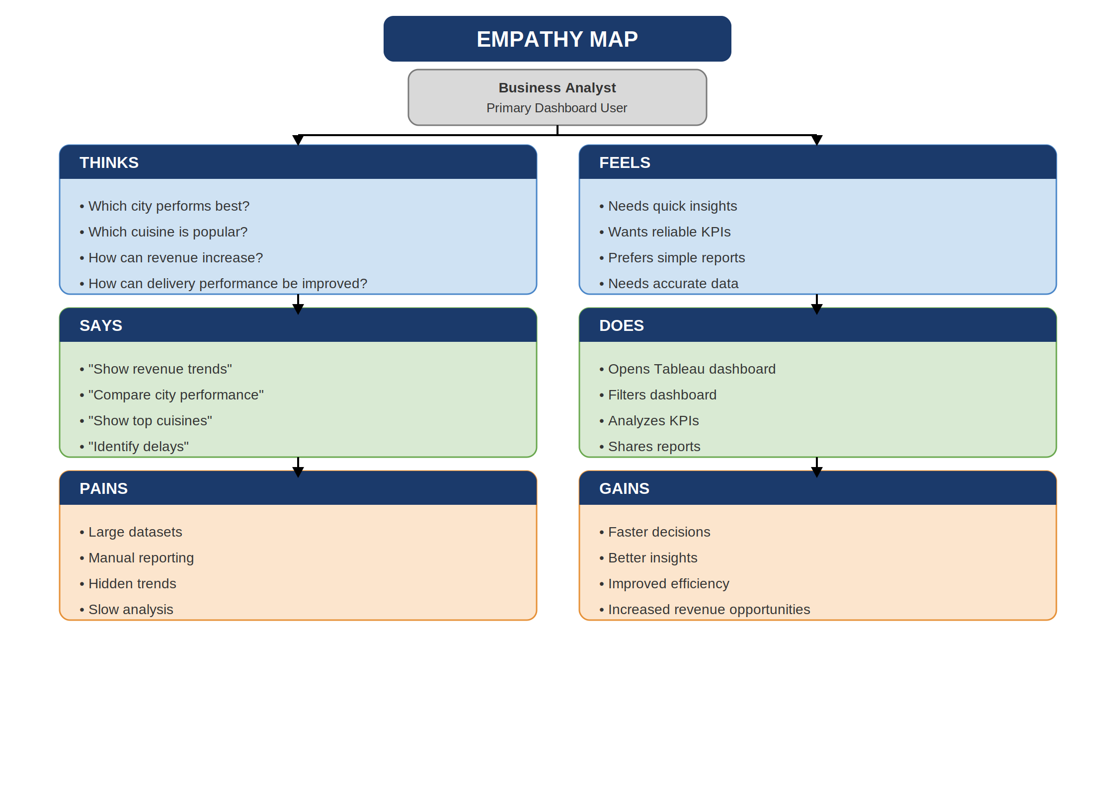

2.3 Brainstorming
A brainstorming session was conducted to identify the most relevant business problems and analytical objectives.
Several ideas were discussed before finalizing the project scope, including:
- Customer behaviour analysis.
- Cuisine popularity analysis.
- City-wise order analysis.
- Revenue contribution analysis.
- Delivery performance evaluation.
- Customer satisfaction monitoring.
- Interactive dashboard development using Tableau.
After evaluating different approaches, the team selected Food Ordering Behaviour and Consumer Trends as the final project because it effectively demonstrates Business Intelligence concepts while addressing practical business challenges.

3. REQUIREMENT ANALYSIS

3.1 Customer Journey Map
The Customer Journey Map illustrates the step-by-step interaction of a Business Analyst while using the Tableau dashboard to analyze food ordering behaviour and consumer trends.
The journey begins with importing the dataset into Tableau, followed by exploring key performance indicators, applying filters, analyzing visualizations, and generating meaningful business insights. Finally, the insights support strategic business decisions aimed at improving operational efficiency and customer satisfaction.
The Customer Journey Map helps identify user interactions, analytical workflow, and decision-making processes throughout the project.
Figure 2. Customer Journey Map
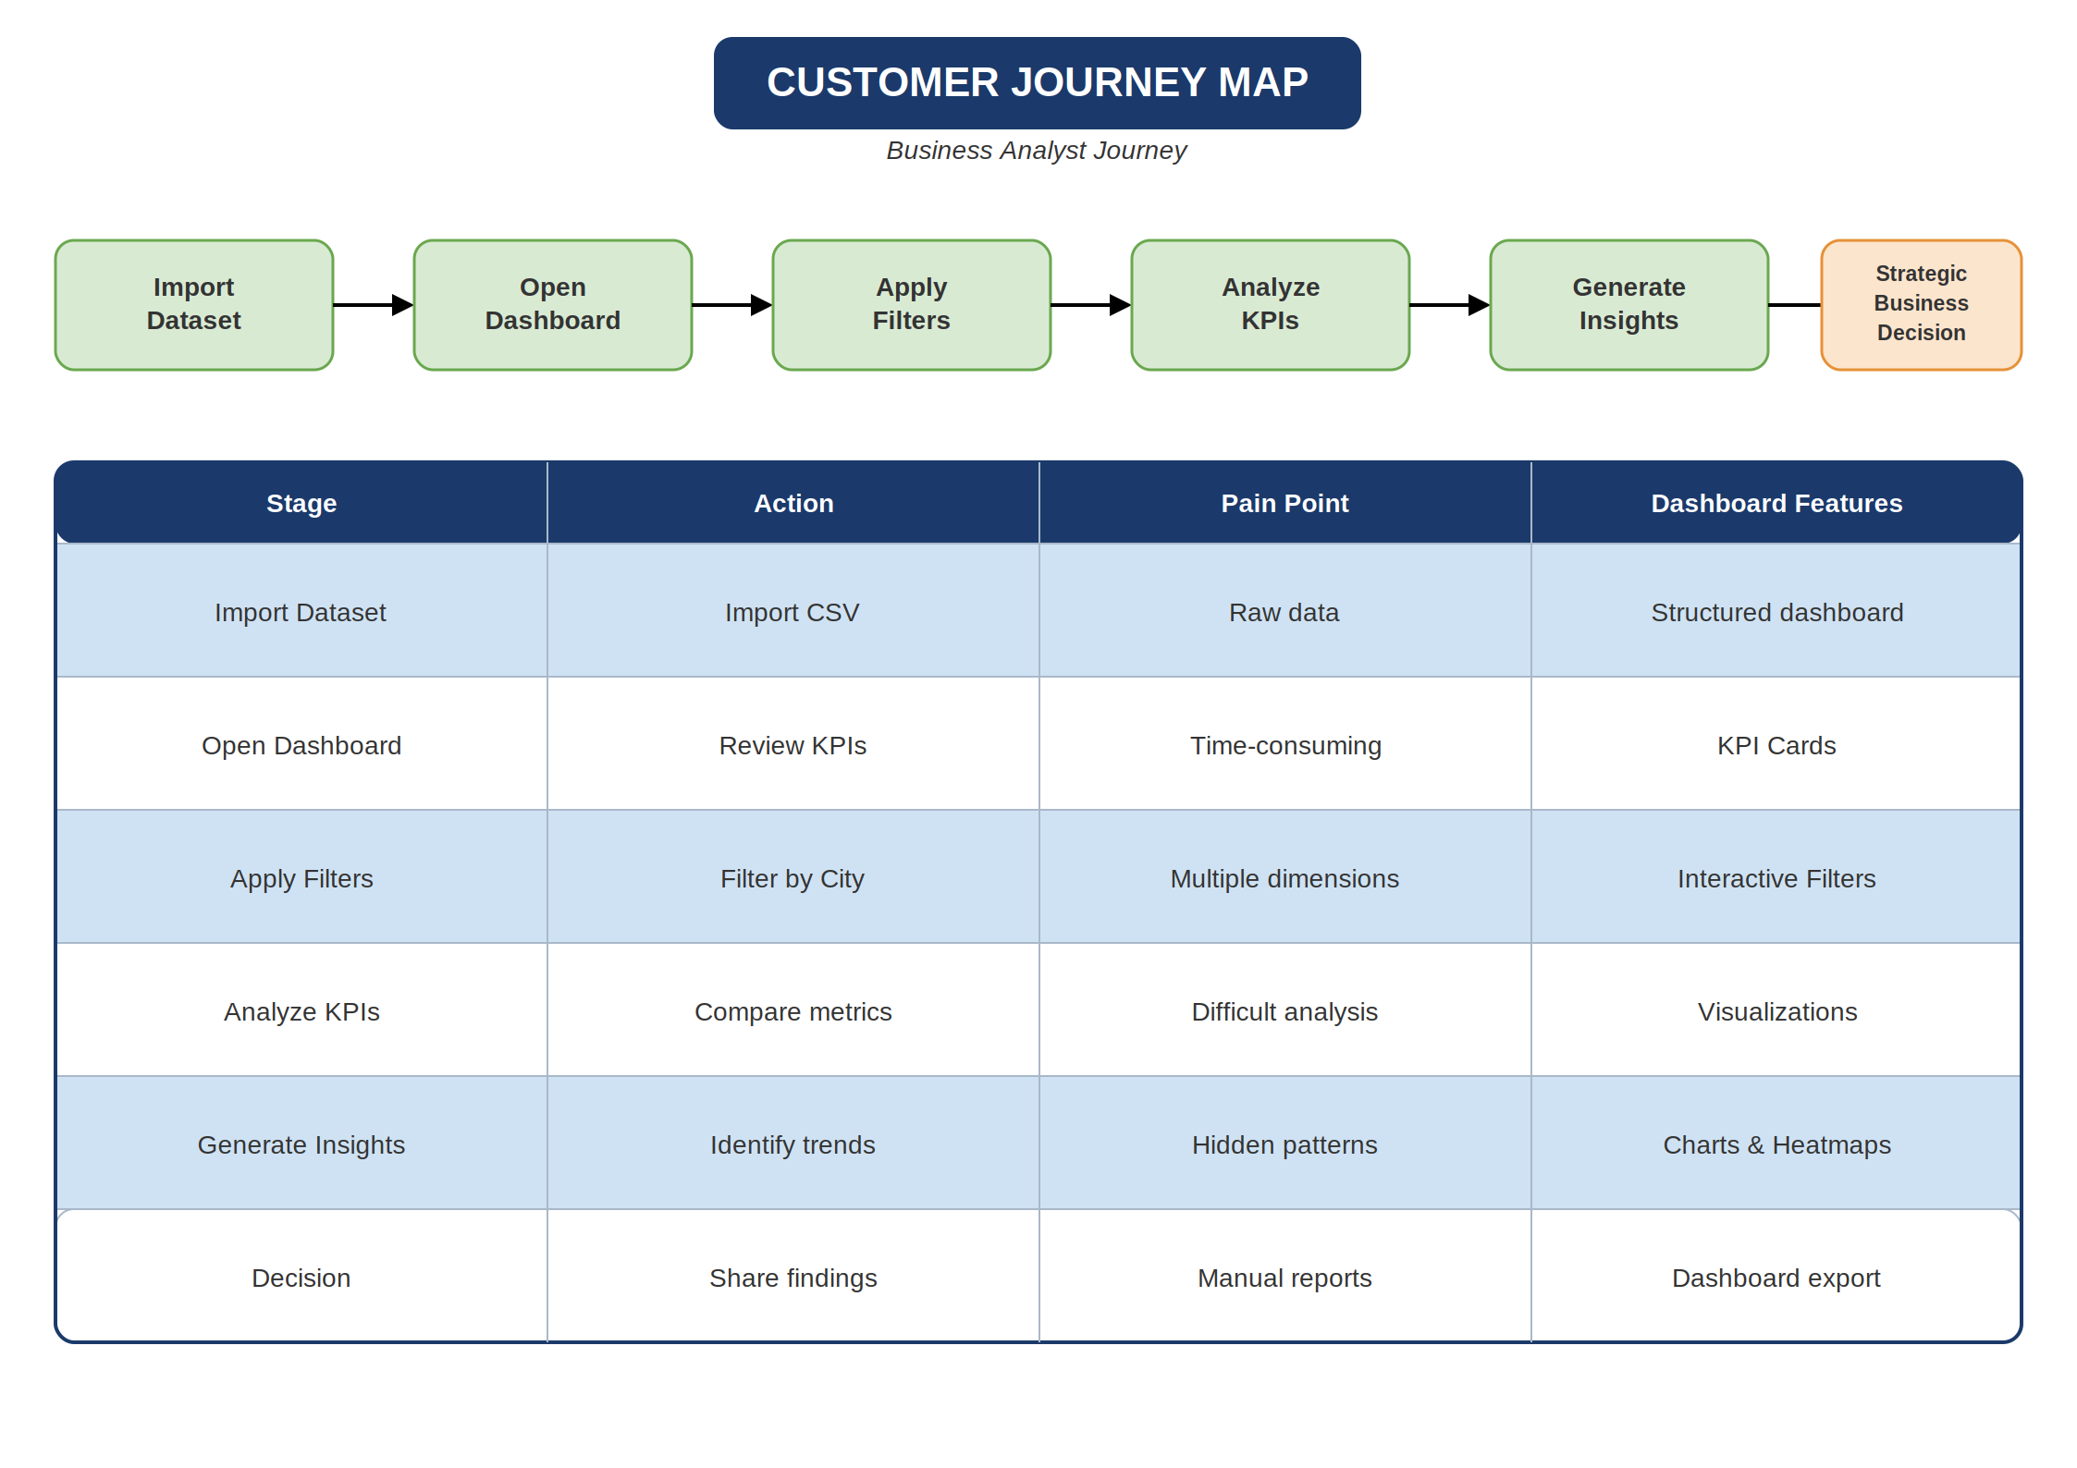

3.2 Solution Requirements
The project requirements were identified to ensure that the dashboard effectively supports business analysis and decision-making.
Functional Requirements
- Import the food ordering dataset into Tableau.
- Display interactive dashboards using multiple visualizations.
- Provide KPI cards summarizing business performance.
- Enable filtering based on different business attributes.
- Support comparative analysis across cities, cuisines, and meal types.
- Present business insights through an interactive dashboard.
Non-Functional Requirements
- User-friendly dashboard interface.
- Fast dashboard rendering.
- Accurate visualization of data.
- Easy navigation between dashboard components.
- Reliable analytical performance.

3.3 Data Flow Diagram
The Data Flow Diagram (DFD) represents the movement of data throughout the project.
The workflow begins with the Food Ordering dataset, followed by data preparation, validation, and transformation. The processed dataset is imported into Tableau, where interactive dashboards are developed to generate business insights and support decision-making.
The DFD illustrates how raw data is transformed into meaningful visual analytics.
Figure 3. Data Flow Diagram
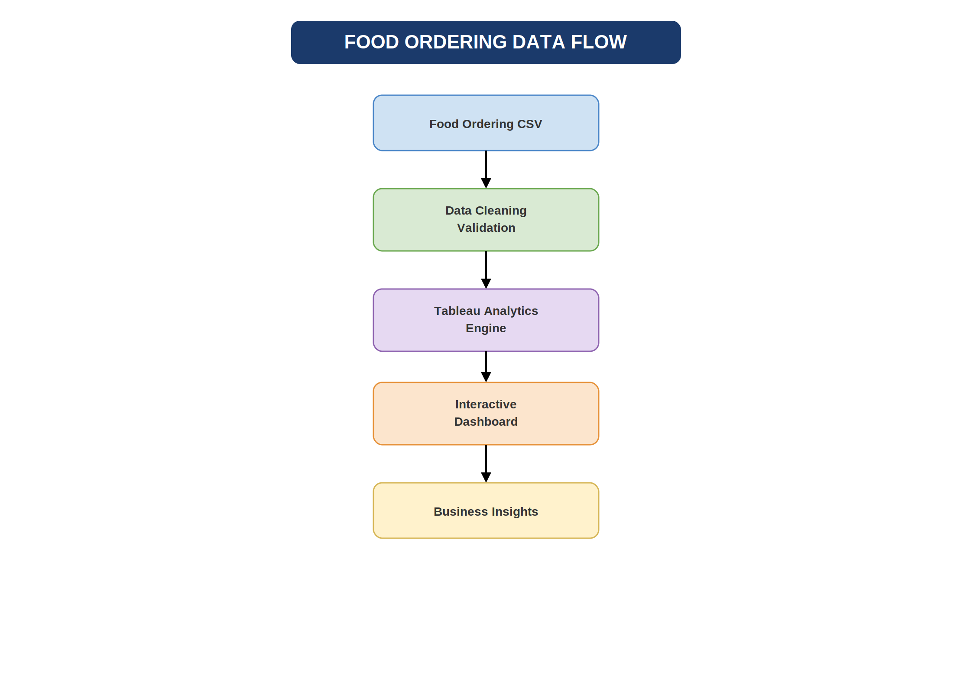

3.4 Technology Stack
The project utilizes modern Business Intelligence tools to perform data analysis and visualization.
Technology | Purpose
Tableau Public | Dashboard Development & Visualization
Microsoft Excel | Dataset Review and Validation
CSV Dataset | Data Source
GitHub | Project Documentation & Version Control

The selected technology stack enables efficient data processing, interactive dashboard creation, and structured project documentation.

4. PROJECT DESIGN

4.1 Problem Solution Fit
The project was designed to address the challenge of extracting meaningful insights from large volumes of food ordering data.
Traditional spreadsheet analysis makes it difficult to identify customer behaviour, revenue patterns, and operational trends. By implementing an interactive Tableau dashboard, the project provides a structured solution that transforms raw transactional data into easy-to-understand visualizations.
The dashboard enables stakeholders to quickly identify trends, compare performance across categories, and make informed business decisions.

4.2 Proposed Solution
The proposed solution is an interactive Business Intelligence dashboard developed using Tableau.
The solution integrates data preparation, visualization, and analytical reporting into a single platform.
The dashboard includes:
- KPI Cards
- Heat Map
- Bar Charts
- Pie Chart
- Revenue Analysis
- Customer Analysis
- Delivery Performance
- Interactive Filters
- Tableau Story
These components work together to provide comprehensive business insights through visual analytics.

4.3 Solution Architecture
The Solution Architecture illustrates the complete workflow of the project.
The architecture begins with the Food Ordering dataset, followed by data validation and preprocessing. The cleaned data is imported into Tableau, where interactive dashboards and stories are created. The dashboards generate business insights that support strategic planning and operational improvements.
The architecture demonstrates the end-to-end implementation of the Business Intelligence solution.

Figure 5. Solution Architecture
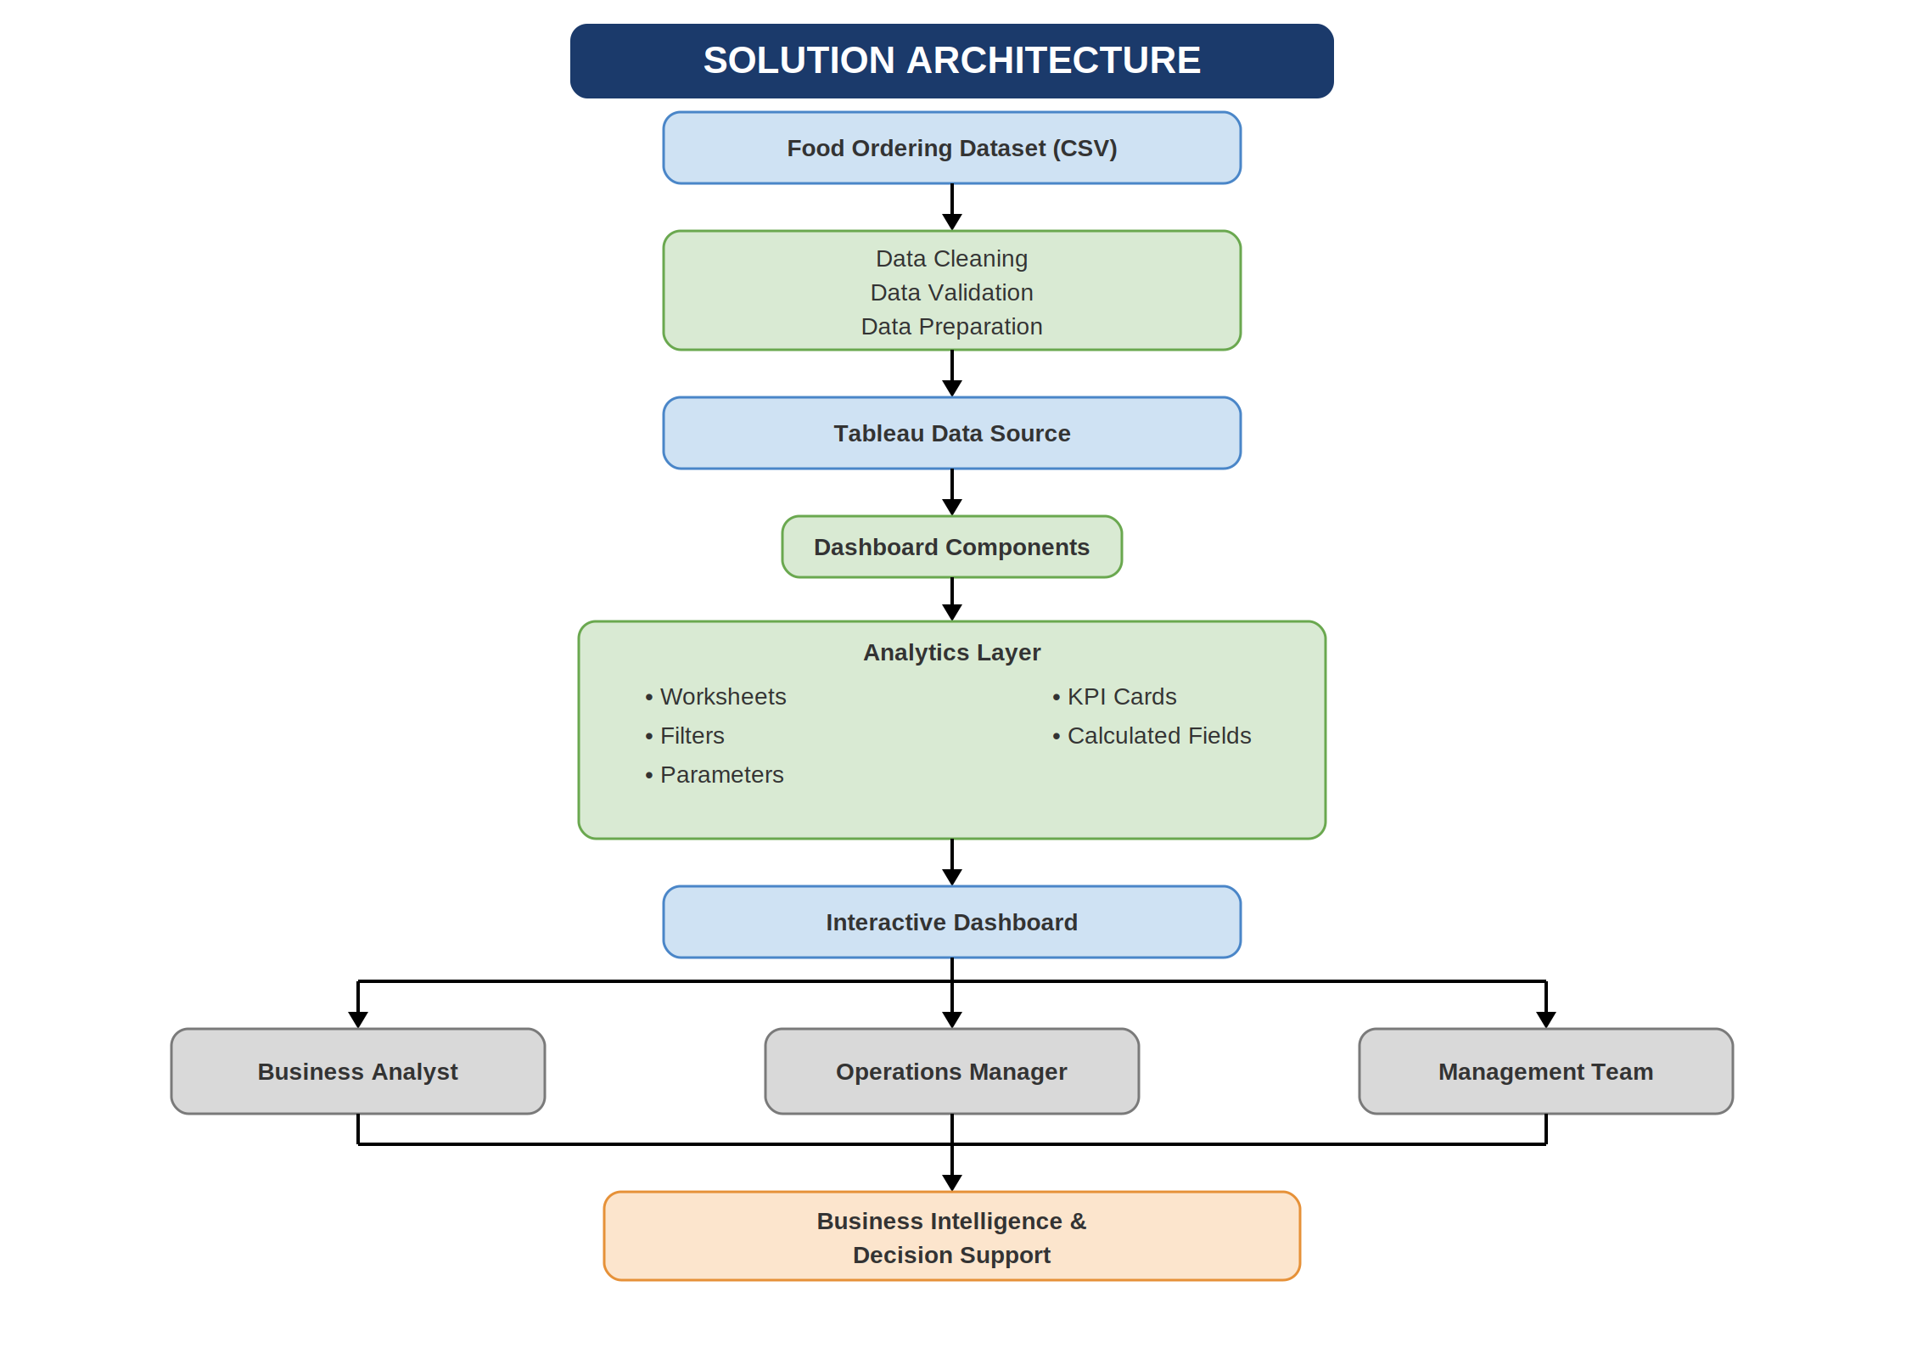

5. PROJECT PLANNING & SCHEDULING

5.1 Project Planning
A structured project plan was followed to ensure the successful completion of the Food Ordering Behaviour and Consumer Trends dashboard. The project was divided into multiple phases, beginning with problem identification and ending with project documentation.
The planning process included requirement gathering, dashboard design, data preparation, visualization development, testing, and documentation. Each phase was completed systematically to ensure the dashboard met the project objectives and delivered meaningful business insights.
Project Phases
Phase | Description
Ideation | Problem identification and brainstorming
Requirement Analysis | Gathering functional and non-functional requirements
Project Design | Solution architecture and dashboard planning
Development | Data preparation and Tableau dashboard creation
Testing | Dashboard validation and performance testing
Documentation | Preparation of reports and GitHub repository

This structured approach ensured efficient project execution and timely completion of all deliverables.

6. FUNCTIONAL AND PERFORMANCE TESTING

6.1 Performance Testing
Performance testing was conducted to verify the functionality, usability, and responsiveness of the Tableau dashboard. The dashboard was tested using different filtering options and visualization components to ensure accurate data representation and smooth interaction.
The evaluation confirmed that the dataset was successfully imported, the dashboard rendered correctly, filters operated as expected, and all visualizations displayed accurate analytical results. The Tableau Story also presented the dashboard insights in a logical and user-friendly sequence.
Performance Testing Summary
Parameter | Status
Dataset Rendering | Successfully Completed
Data Preprocessing | Successfully Completed
Filter Functionality | Successfully Completed
Dashboard Rendering | Successfully Completed
Story Navigation | Successfully Completed
Dashboard Performance | Successfully Completed

The dashboard demonstrated reliable performance throughout the testing process and effectively supported interactive business analysis.

7. RESULTS

The final Tableau dashboard successfully transformed raw food ordering data into interactive visualizations, enabling users to analyze customer behaviour, revenue trends, cuisine preferences, and delivery performance.
The dashboard integrates multiple charts and KPI cards into a single interface, allowing stakeholders to explore business insights through filters and interactive components.
The Tableau Story further enhances the analytical process by presenting the dashboard findings in a structured sequence, making it easier for users to understand trends and derive meaningful conclusions.
Figure 6. Interactive Tableau Dashboard
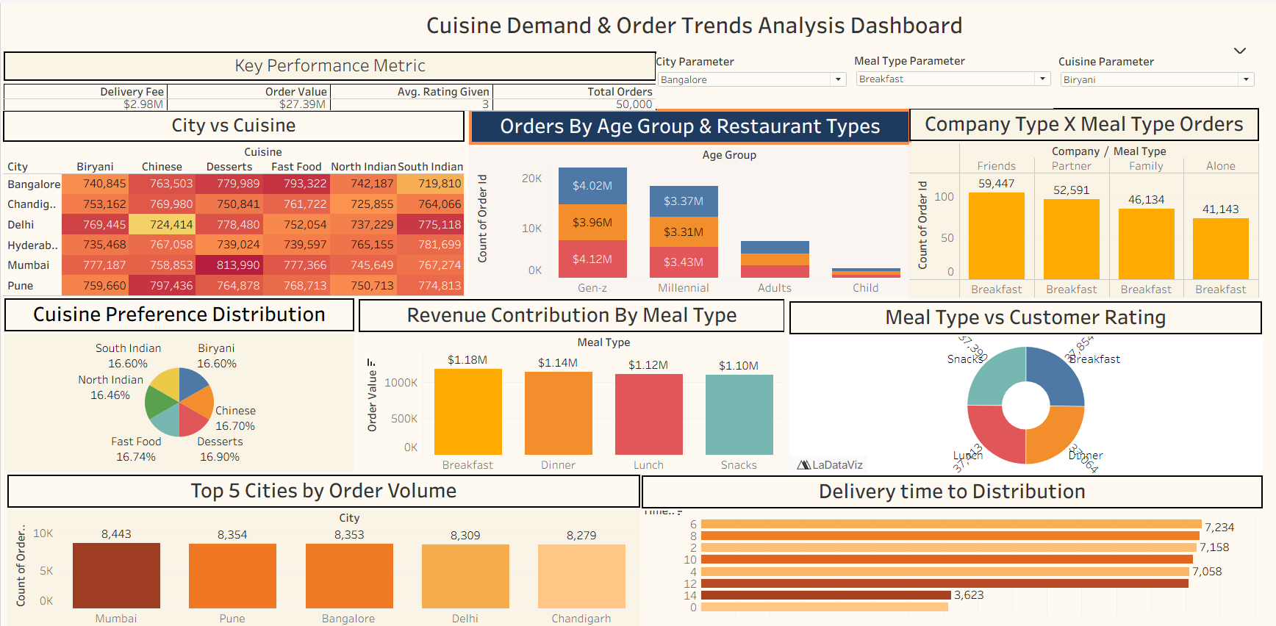

Figure 7. Tableau Story
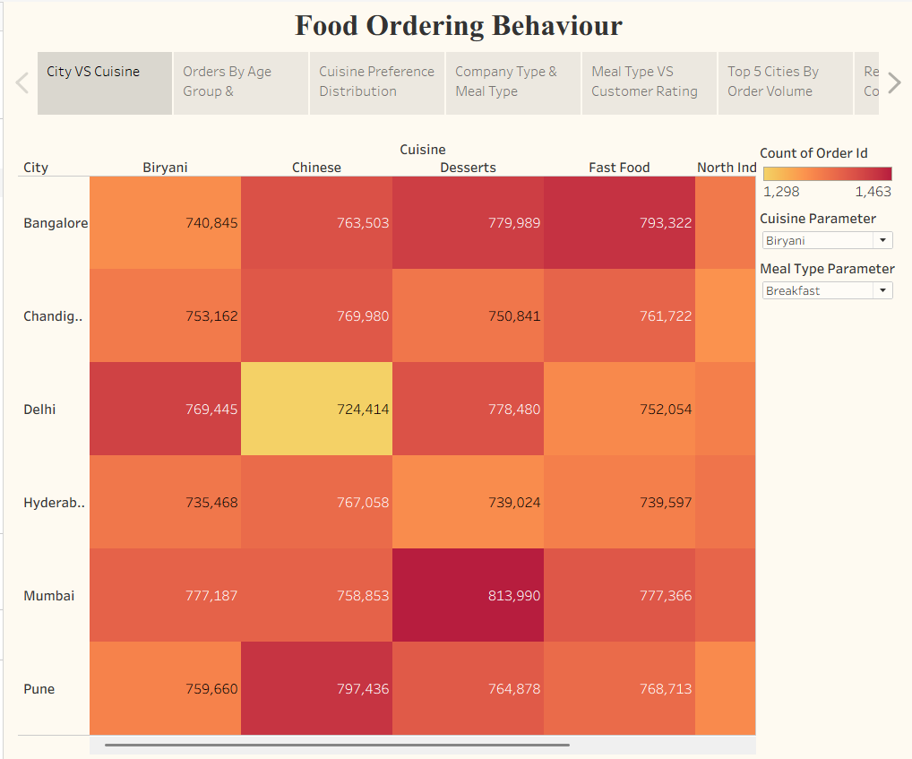
The developed dashboard provides an effective Business Intelligence solution by simplifying complex data into visually understandable insights that support data-driven decision-making.

8. ADVANTAGES & DISADVANTAGES

8.1 Advantages
The Food Ordering Behaviour and Consumer Trends dashboard provides several advantages for business analysis and decision-making.
- Interactive dashboard enables easy exploration of data.
- Visualizations simplify complex business information.
- KPI cards provide a quick overview of business performance.
- Filters allow dynamic analysis across different categories.
- Supports data-driven decision-making.
- Helps identify customer behaviour and ordering trends.
- Improves understanding of revenue and delivery performance.
- Provides an organized and user-friendly analytical interface.

8.2 Disadvantages
Although the project provides valuable insights, it has certain limitations.
- Analysis is limited to the available dataset.
- Dashboard insights depend on the accuracy of the source data.
- Real-time data integration is not available.
- Predictive analysis is not included.
- External business factors are not considered in the current analysis.

9. CONCLUSION
The Food Ordering Behaviour and Consumer Trends project successfully demonstrates the application of Business Intelligence techniques using Tableau. By transforming raw food ordering data into interactive visualizations, the dashboard enables users to analyze customer behaviour, revenue patterns, cuisine preferences, and delivery performance efficiently.
The project highlights the importance of data visualization in supporting business decision-making. Through KPI cards, charts, filters, and interactive dashboards, stakeholders can easily identify trends, monitor key performance indicators, and derive actionable insights.
Overall, the project achieves its objective of providing an intuitive and effective analytical solution for understanding food ordering behaviour and consumer trends.

10. FUTURE SCOPE
The project can be further enhanced by incorporating advanced Business Intelligence and data analytics features.
Future improvements include:
- Integration with real-time food ordering databases.
- Development of predictive analytics models for demand forecasting.
- Implementation of machine learning techniques for customer segmentation.
- Personalized food recommendation systems.
- Cloud-based dashboard deployment for remote accessibility.
- Mobile-friendly dashboard design.
- Automated reporting and scheduled dashboard updates.
- Integration with additional business performance metrics.
These enhancements would improve the scalability, accuracy, and overall effectiveness of the dashboard.

11. APPENDIX

11.1 Source Code
The project was developed using Tableau Public, where dashboard development was performed through visual analytics without traditional programming code. The project files include the Tableau workbook, dashboard configurations, and supporting documentation maintained in the GitHub repository.

11.2 Dataset Link
Dataset Name: Food Ordering Behaviour Dataset
Source type : CSV

11.3 GitHub Repository
GitHub Repository Link: GitHub URL
The repository contains:
- Project documentation
- Dashboard reports
- Dataset
- Tableau workbook (if included)
- Diagrams and supporting files

11.4 Project Demo Link
Tableau Public Dashboard: Tableau Public dashboard link
Project Demo Video: [Paste your YouTube or Google Drive demo video link here.]
The published dashboard allows users to interact with the visualizations online, while the demo video provides a walkthrough of the project's features and functionality.

REFERENCES
- Tableau Public Documentation
- Microsoft Excel Documentation
- Tableau Desktop User Guide
- Food Ordering Behaviour Dataset
- GitHub Documentation

